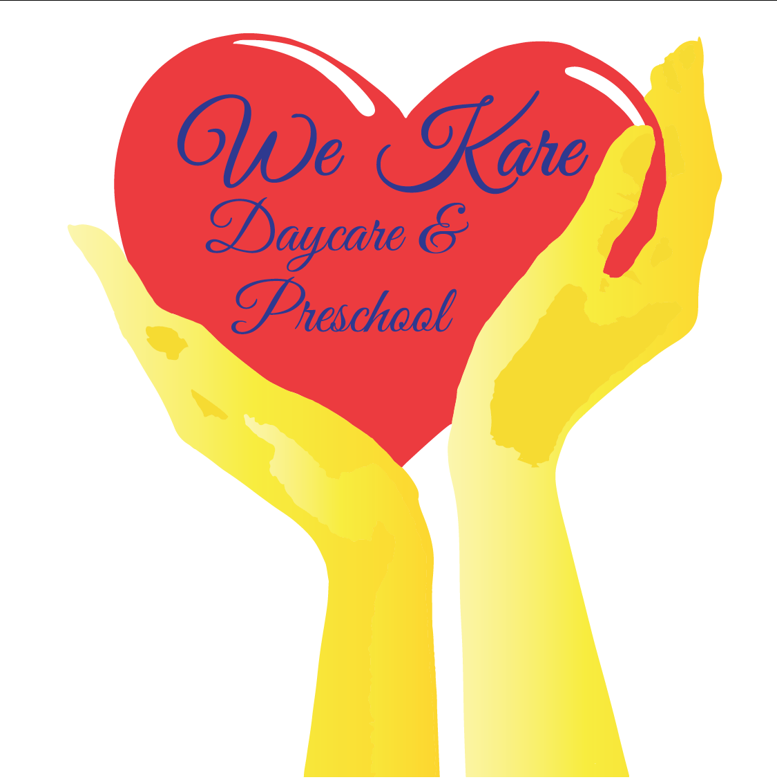
We Kare Daycare & Preschool
Caring & loving for your child like our own!

We’re in this together!

Our Vision is to have all children treated with respect, honesty, love, care, and devotion, while implementing the love of God through displaying and showing acts of the love of God for all children, parents, staff, and any one that comes in contact with one of our staff members!

We Kare Daycare & Preschool is an Educational Center, and Our Goal is to prepare all children for the future by teaching every child on their level to ensure success when they enter into kindergarten!

